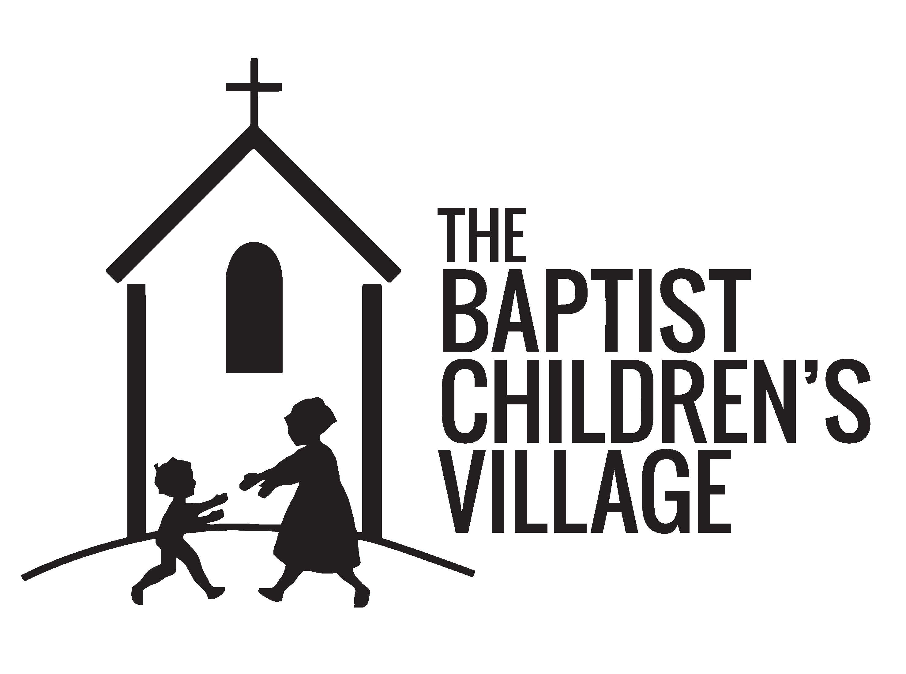
The Baptist Children's Village Project List Options

Immune Boosters
Multi-Vitamins
(Gummies and Chewable)
Fresh Fruit (Apple, Pineapple, Grape, Orange)
Fruit Juice
Canned Fruit (100% Juice)
Dried Fruit (Cranberries, Blueberries
Kids' Favorites
Spaghetti Sauce/Spaghetti
Goldfish/Snack Crackers
Gummy Fruit Candies
Nutella
Gum (Sugar Free)
Kosher Dill Pickles
Build A Bathroom Basket/Laundry Hamper
Bath Towel & Wash Cloth
Toilet Tissue
Toilet Brush
Toilet Cleansers/Deodorizers
Soap or Body Wash
Deodorant
Shampoo & Conditioner
Breakfast Box
Variety Oatmeal (Instant/ Regular)
Grits
Pop Tarts/Breakfast Bars
Muffin Mixes
Biscuit/Pancake Mixes
Jelly/Syrup (No High Fructose)
Juice (With Vitamin C)
Cereal (Preferably Whole Grain like Honey Nut Cheerios, Raisin Bran, Honey Bunches of Oats, Honey Grahams, Cheerios
(Generic Brands are fine)

114 Marketridge Drive • Ridgeland, MS 39157 • 601-952-2422 Phone • 601-952-2906 (Fax)
baptistchildrensvillage.com

Cleaning Supplies
Lysol disinfectant cleaners
Tub/tile mildew/stain cleaners
Disinfectant Spray
Dish Detergent
Dishwasher Detergent
(Prefer gel types)
Lemon Ammonia

Snacks/Drinks
Nabs/Crackers
Teddy Grahams/Goldfish
Variety Chips (Tortilla, Doritos, Cheetos)
Sports Drinks
Juice Boxes/Capri Sun
Protein Bars/Nutrigrain Bars
Raisins
Mixed Nuts

Movie Night
G or PG Rated DVD's or Movie Theater Passes
Popcorn/Snacks
Pudding/Jello Snacks
Drinks (Sodas-Sprite, Rootbeer, 7-Up, Orange, Grape)
Assorted Chocolate (Snack Size)
Fruity Candy

Holiday Baking
Biscuit Mix
Salt/Pepper
Sugar
Chocolate/Butterscotch Chips
Sweetened Condensed Milk
Evaporated Milk
Pie Fillings
Nuts (pecans, walnuts, almonds, etc.)
Pie Shells
(graham cracker & regular)
Rice Krispies
Marshmallows

Kitchen Essentials
Garbage bags
(13-gal, 30 & 33-gal)
Plastic wrap/Parchment Paper Foil
Paper plates/Cups/
Plastic Ware for Picnics
Storage & Freezer bags (sandwich, quart, gallon)
Paper Towels
Baby/Hand Wipes
Laundry Supplies
Laundry Detergent (Liquid)
Laundry stain remover
Bleach
Dryer Sheets
Fabric Softener
Borax
Holidays Needs
Batteries (AA, AAA, D, C, 9-Volt)
Movie Passes
Museum Tickets
Hot Chocolate Mix/Ovaltine
Gift Cards
Walmart
Best Buy
Lowes/Home Depot
J C Penney
Chick Fil A
Pizza Hut/Mazzio’s
Little Caesars
McDonald's/Wendy’s
Burger King/Sonic
Cracker Barrel
Barnes & Nobles
(These are ideas. Any chain restaurant/store works for
our statewide campuses)
Homemade Casseroles to put in the freezer are great anytime for houseparents to pull out on those especially hectic days.

